UNIVERSITY INSTITUTE OF COMPUTING
PROJECT REPORT ON
Linux System Installation and Configuration

Program Name: BCA
Subject: Linux Administration
Code: 23CAP-305

SUBMITTED BY: SUBMITTEDTO:
Name: Kritika Name: Rajat Kapoor
UID: 23BCA10554 Designation: Asst. Professor
Branch:BCA
Section/Group:3-B
Semester:5th

BONAFIDE CERTIFICATE
Certified that this project report “Linux System Installation and Configuration” is the bonafide work of Kritika, UID 23BCA10554, who carried out the project work under my supervision.
Signature: ____________________________
Assistant Professor, UIC Department
Rajat Kapoor

- TABLE OF CONTENTS
- Aim of the Project
- Introduction
- Objectives
- System Requirements
- Tools and Technologies Used
- Implementation Steps
- Project Methodology
- Algorithm / Logic / Flowchart
- Code Overview
- Output
- Challenges Faced
- Conclusion
- Learning Outcomes

- AIM OF THE PROJECT
To install, configure, and verify a Linux operating system (Ubuntu/CentOS), perform network configuration, update packages, and test system connectivity for a fully functional and secure environment.

- INTRODUCTION
Linux is a powerful and open-source operating system widely used for servers, system administration, and development environments.
This project aims to provide hands-on experience in installing and configuring a Linux OS on a physical or virtual system. The implementation includes disk partitioning, package management, hostname setup, and network configuration using command-line tools.
The project helps students understand the practical aspects of Linux administration, preparing them for advanced system management and DevOps roles.

- OBJECTIVES
- Install and configure a Linux distribution (Ubuntu or CentOS).
- Learn manual disk partitioning during installation.
- Configure hostname and networking using system commands.
- Manage software packages using APT/YUM.
- Verify network connectivity and system performance.
- Develop foundational system administration skills.

- SYSTEM REQUIREMENTS
Hardware Requirements:
- Processor: Intel Core i3 or higher
- RAM: 2 GB minimum (4 GB recommended)
- Disk Space: 25 GB minimum
- Internet: Required for package updates

Software Requirements:
- Linux Distribution: Ubuntu 20.04 LTS / CentOS 8
- Virtualization Tool: VirtualBox / VMware
- Text Editor: nano / vim
- Privileges: Root or sudo access
Prerequisites:
- Basic Linux commands
- Understanding of networking and filesystems

- TOOLS AND TECHNOLOGIES USED
- Operating System: Ubuntu / CentOS
- Shell: Bash
- Commands: ifconfig, hostnamectl, apt, yum, ping, uname, df
- Utilities: net-tools, curl

- IMPLEMENTATION STEPS
- Select the Linux Distribution: Choose Ubuntu or CentOS.
- Create Installation Media: Bootable USB or ISO image.
- Install Linux:
  - Manual partitioning (/, /home, swap)
  - Configure timezone and user credentials
- Configure Network Settings:
  - Use ifconfig or ip to view interfaces
  - Set hostname using hostnamectl
  - Configure IP in /etc/network/interfaces or via nmcli
- Update and Install Packages:
  - sudo apt update && sudo apt upgrade (Ubuntu)
  - sudo yum update (CentOS)
- Test Connectivity:
  - ping google.com
- Verify System Information:
  - uname -a, df -h, free -m

- PROJECT METHODOLOGY
Phase 1 – Planning:
Selected appropriate Linux distribution and installation method.
Phase 2 – Installation:
Installed Linux OS using manual disk partitioning.
Phase 3 – Configuration:
Set hostname, network parameters, and installed core utilities.
Phase 4 – Testing:
Tested network and verified package updates.
Phase 5 – Documentation:
Recorded each step and verified outcomes with screenshots.

- ALGORITHM / LOGIC / FLOWCHART
Algorithm:
- Boot from installation media.
- Select language and perform disk setup.
- Install base system and set user credentials.
- Configure network settings and hostname.
- Update repositories and install packages.
- Test network connectivity.
- Verify system information.
Workflow Diagram:
Start
↓
Choose Linux OS
↓
Create Bootable Media
↓
Install Linux OS
↓
Configure Partitions & Network
↓
Install Packages and Updates
↓
Test Configuration
↓
System Ready
↓
End

- CODE OVERVIEW
# View network interfaces
ifconfig

# Set hostname
sudo hostnamectl set-hostname myserver

# Update and upgrade system
sudo apt update && sudo apt upgrade -y # Ubuntu
sudo yum update -y # CentOS

# Install essential utilities
sudo apt install net-tools vim curl -y

# Check system info
uname -a
df -h
free -m

# Test network connectivity
ping google.com

- OUTPUT
- Successful Linux installation screenshot.
- ifconfig showing network configuration.
- Hostname updated successfully.
- System updated via APT/YUM.
- Network connectivity test successful.
- Verified system disk and memory info.

SCREENSHOT:
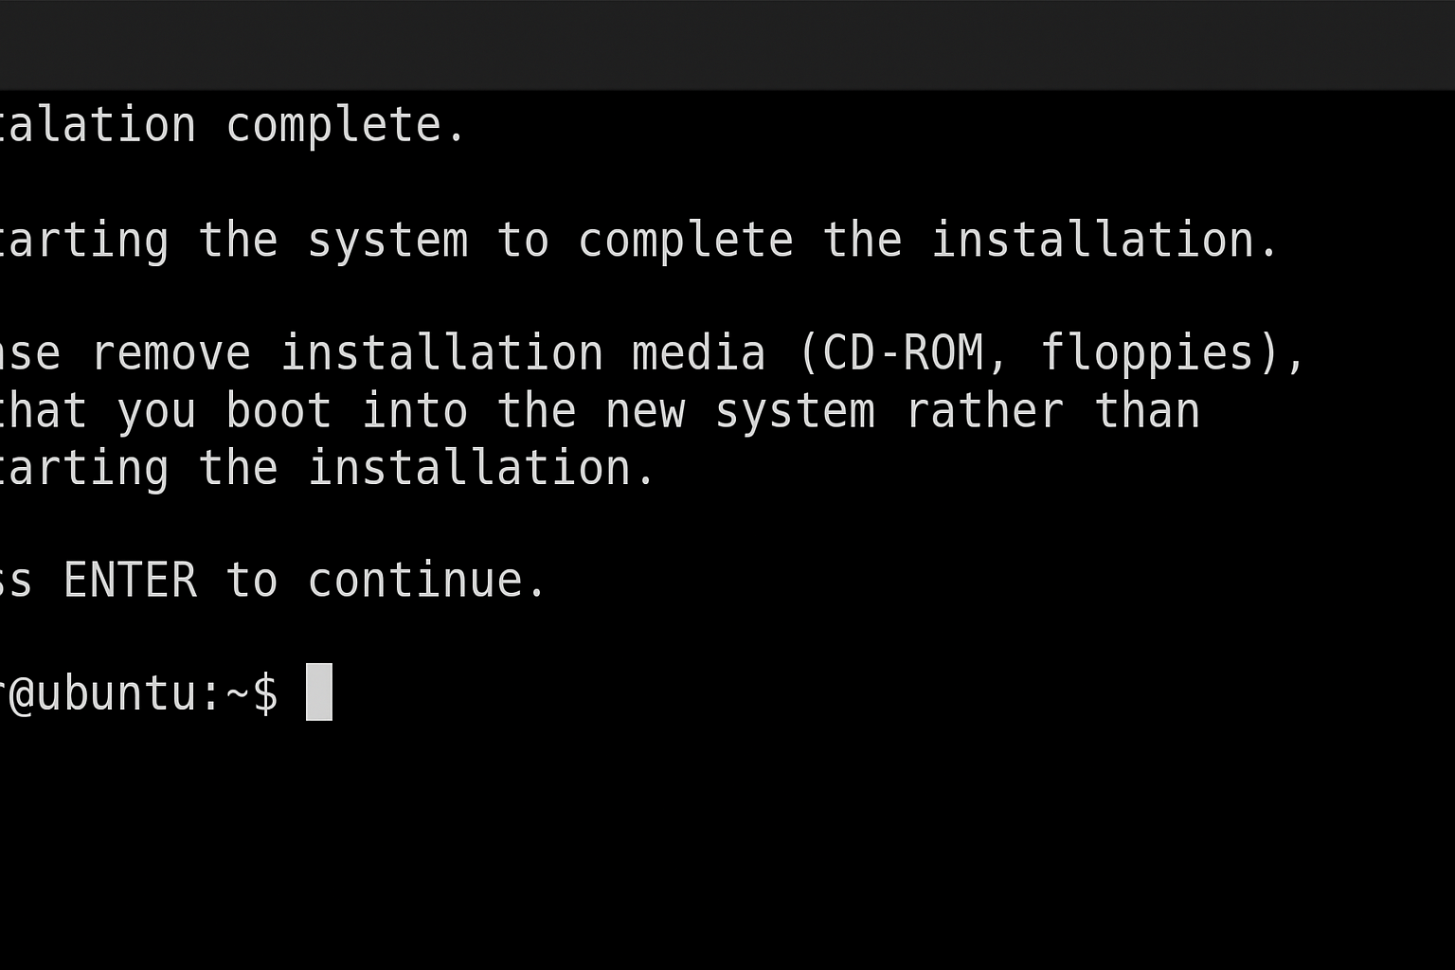

- CHALLENGES FACED
- Disk partitioning confusion during setup.
- Network configuration errors in static IP assignment.
- Package repository connection issues.
- Permissions required for system-level commands.

- CONCLUSION
The project successfully demonstrates the installation and configuration of a Linux operating system.
Students gained practical exposure to Linux administration concepts, including partitioning, networking, package management, and system verification.

- Future Enhancements
- Automated Installation Script
  - Develop a Bash or Python script to automate installation steps (partition setup, network config, package installation).
- GUI-Based Installer
  - Integrate a graphical interface using tools like Anaconda or Calamares for easier installation and configuration.
- Cloud Deployment Support
  - Extend the setup for automated deployment on cloud platforms (AWS, Azure, or Google Cloud).
- Configuration Management Integration
  - Use tools such as Ansible, Puppet, or Chef to manage and replicate configurations across multiple systems.
- Custom ISO Creation
  - Build a customized Ubuntu ISO that includes pre-installed utilities and configurations.
- Security Hardening
  - Automate firewall setup (UFW/iptables), SSH hardening, and system auditing as part of the installation.
- Post-Installation Verification
  - Include automated tests to verify system health, disk usage, network connectivity, and performance benchmarks.
- Backup and Recovery Setup
  - Implement an optional feature to configure regular backups and quick recovery options during installation.
- Multi-OS Support
  - Extend compatibility to support other Linux distributions (CentOS, Fedora, Debian) using conditional logic.
- Monitoring Integration
  - Add monitoring setup using Prometheus or Nagios for system resource tracking and alerting.
- LEARNING OUTCOMES
- Learned step-by-step Linux OS installation.
- Understood filesystem and partition structure.
- Gained hands-on experience with Linux commands.
- Enhanced troubleshooting and network configuration skills.
- Built a strong foundation for advanced Linux system administration.

